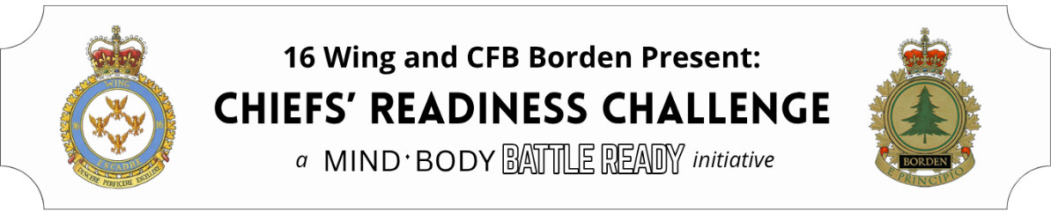

Identity Statement
Challenges/Goals | Reinforcing Systems | Supporting Habits
Inspired by James Clear’s Atomic Habits, an identity statement is a purposeful description of the person you want to be. This statement can include all facets of your personal and professional life and should provide a clear vision from which you will design your daily, weekly, and monthly habits. This statement can evolve over time as the vision you have for yourself grows.

