

DESIGNATED ROUTES

- The following two (2) routes are designed for Units to select from when participating in the Unit Wellness Walk event for CAF Sports Day 2026. When selecting the route, it is imperative that the Team Captain considers the fitness levels of their participants and the time available to the Unit to conduct this activity.

- Each route varies in length and can easily be modified to have Units start and finish at their Unit location, if preferred. Exact distances covered can be easily measured by employing GPS technology.

- Option 1: Walk the Fairway (Round Trip 4.7km)

- this is an out and back route starting at the Col J.J. Parr Sports Centre, with the turnaround point at Cold Lake Golf and Country Club (i.e., “the curling rink”).

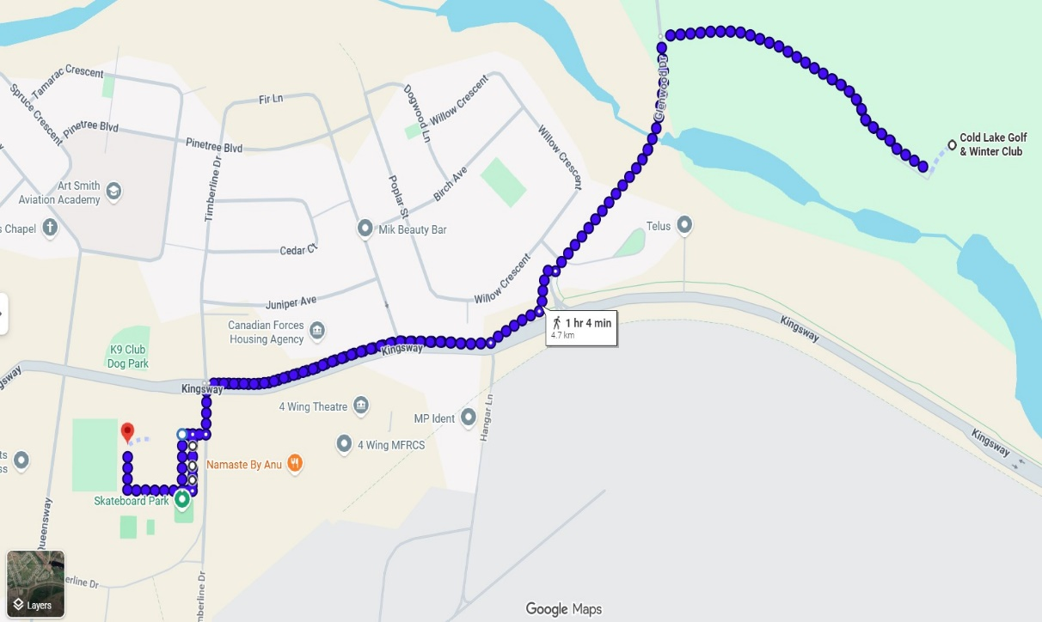

Potential risks: road/lane use (intersections); sidewalk access; traffic

- Option 2: Sleepy Tin Town (3.8km)

a. this is a loop route starting at the Col J.J. Parr Sports Centre, looping
through the 4 Wing Campground (i.e., “Tin Town”) before returning to Col J.J. Parr Sports Centre.

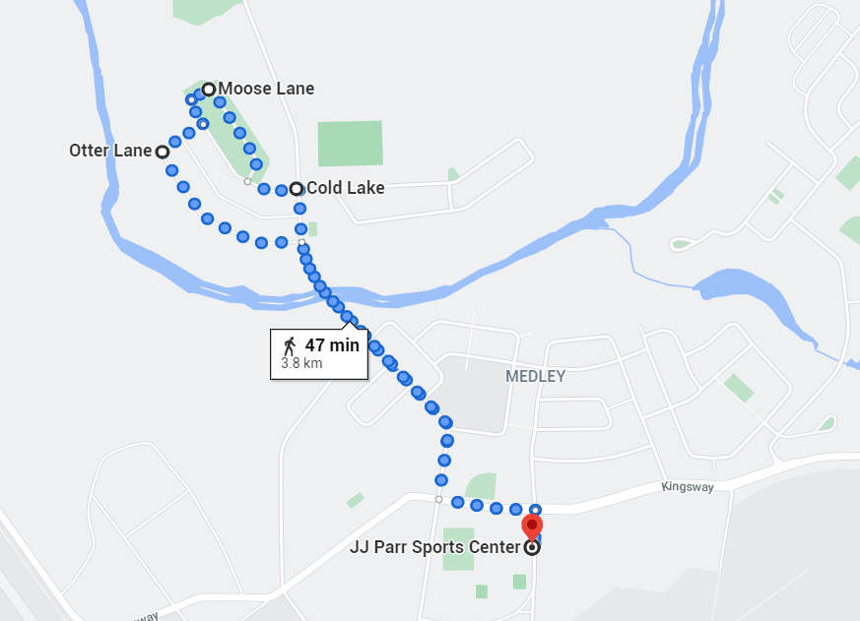
Potential risks: road/lane use (intersections); sidewalk access; uneven/adverse terrain; traffic – vehicles and other pedestrians

