Summer 2025

MCpl J.J.P Legault Fitness & Wellness Centre
Summer Camp
Parent Handbook

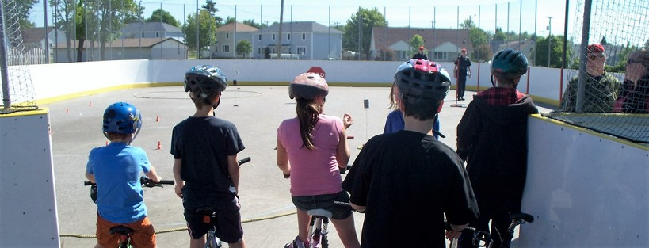

MCpl J.J.P Legault Fitness & Wellness Centre
29 Duxford Rd, Hornell Heights
705-494-2011 ext. 2610

22 Wing Ayr Mess – Club 100
17 Duxford Rd, Hornell Heights
(Located beside the Canex)

Welcome to Summer Camp!

Dear Camper Families!

Welcome to the 22 Wing Summer Camp! We are thrilled to host camp and provide an exciting and memorable experience for your child(ren). As a registered High Five® organization, we are dedicated to ensuring that every child has the best possible summer camp experience. Our goal is to create an environment where children can make new friends, learn new skills, and create lasting memories.

To help ensure your child has a positive and enjoyable experience, we’ve created this Parent Handbook. It contains everything you need to prepare both you and your child for the exciting activities we have planned, rain or shine.

Inside, you’ll find all the important information necessary to support your child’s enjoyment and safety at camp. A few key reminders: all permission forms and waivers must be completed and either mailed or dropped off on the first day of camp. If your family has any special needs or if there is anything we can do to improve your child’s experience, please let us know. Additionally, if you would like to register for any extra weeks, we are happy to accommodate sign-ups throughout the summer, provided space is available.

Thank you for trusting our recreation team to provide a fun and enriching summer camp experience for you and your child(ren). We look forward to a fantastic summer together!

Sandra Brownlee
Community Recreation Supervisor
Brownlee.sandra@cfmws.com
705-494-2011 ext. 2617

General Camp Information

OUR PROGRAM & COUNSELORS
Our camp is specifically designed for children ages 6 to 12. To ensure personalized attention, we maintain lower ratios even in our largest groups, with all campers closely supervised by our trained staff.

Every camp counselor is certified in First Aid, CPR, and AED, and they are always equipped with a first aid kit. Additionally, all counselors are trained in the High Five® Principles of Healthy Child Development, ensuring a safe and supportive environment for your child.

HIGH FIVE
We are a HIGH FIVE registered organization. HIGH FIVE is Canada’s quality standard for children’s recreation and sport for ages 6-12 years. HIGH FIVE holds true to the five principles of healthy child development that the research indicates are essential for quality programs:

- A caring adult
- The opportunity to make friends
- The opportunity to play
- The opportunity to master skills and
- The opportunity to participate

CAMPER CODE OF CONDUCT
To make sure everyone has a safe and fun time at camp, we have a few important guidelines that all campers must follow. These rules are here to help everyone enjoy their time and stay safe. If any camper chooses not to follow these guidelines, they will be spoken to and given a clear explanation of what is expected. If a camper continues to make poor choices, we may need to set up a meeting with their parents, counselors, and the program manager to work together to prevent any future issues.

We have a ZERO tolerance policy for bullying, aggressive behavior, or violence. This means that any behavior that harms or hurts others will not be allowed. Each situation will be handled fairly and respectfully, but please be aware that serious or repeated behavior problems may result in the camper being removed from the program.

We want everyone to have a great experience at camp, and following the rules helps us make that happen! Let's work together to create a fun, kind, and safe environment for everyone.

MEDICATION
All medication is to be handed to a Counsellor at the beginning of each day (or week), no child is to carry medication in their belongings (except for EpiPens). All medication must be in its original container and a Medication Consent Form must be completed and submitted to the PSP upon registration. A dispensing record for each child requiring medication will be kept and maintained by PSP staff.

Payment & Prices
Payment for camp must be paid in full upon registration. Registration for camp is for a minimum of 1 week at a time, daily registration is not available.

Regular/Military Members: $130/week
Ordinary/RAM Members: $155/week
Non-Members/General Public: $180/week

Before and after care is available for $3/session. Before care runs from 7:30am-8:00am and after care runs from 4:00pm-4:30pm.

REFUNDS
There will be no refunds issued for camp once a child is registered for the program. In addition, absences due to illnesses throughout the week at camp will not be considered for refunds. Considerations for military operations and serious medical emergencies will be accepted with documentation on a case-by-case basis through the Community/Recreation Supervisor Sandra Brownlee (705)-494- 2011 ext. 2617 or brownlee.sandra@cfmws.com.

What to expect at Camp
SIGN IN/OUT
Regular camp programming will run from 8:00 am-4:00 pm. Before/after care is available for an additional fee. Before care is available from 7:30 am-8:00 am and after care is available from 4:00 pm-4:30 pm.

Camper drop off and pick up will take place at the 22 Wing Ayr Mess – Club 100
17 Duxford Rd, Hornell Heights (Located beside the Canex). Parents/Guardians or those authorized to pick campers up are asked to respect the pick-up time, and to show photo ID upon signing any child out of camp. Only those listed as a guardian or authorized pick-up will be permitted to sign a child out of camp. Arrangements to have someone added to the authorized pick-up list must be made no later than the morning of the drop-off.

ITEMS TO BRING
Campers are expected to bring the following items to and from camp each day. PSP staff are not responsible for lost or stolen items, please ensure all items are labeled with your child’s name.
- A change of clothes that may get wet/dirty
- Swimsuit
- Towel
- A bag for wet swim wear
- Athletic shoes
- Water bottle
- Lunch
- Minimum of 2 Snacks
- Sunscreen
- Hat
We kindly ask that campers refrain from bringing personal items like electronic devices or toys from home. This helps everyone stay focused on the fun activities and ensures a smooth, enjoyable camp experience. If a camper is seen using or bringing these items, they will be held by the counselors and returned at the end of the day.

LUNCHES & SNACKS
Campers are required to bring their own lunch and snacks. There will be a lunch break as well as two snack breaks throughout the day, so please ensure your child is packed with enough food to keep them fueled and energized. PSP staff do not provide lunch or snacks, and campers will not have access to a refrigerator or microwave. Thank you for helping us ensure your child is well-prepared for a fun-filled day at camp!

FACILITIES
In order to provide the best experience for your child we will be using a variety of facilities within the 22 Wing Community. These facilities include:
- The Pool & Gymnasium at the Fitness & Wellness Centre at 29 Duxford Rd
- The outdoor Playground behind the Community Centre on Market St
- The 22 Wing Museum

DAILY SCHEDULE
*This is a sample schedule and is subject to change based on daily and weekly activities.

7:30-8:15 AM | Arrival/free time
8:30-9:30 AM | 1st Daily Sport/Activity
9:30-9:45 AM | 1st Snack
9:45-11:15 AM | 2nd Daily Sport/Activity
11:30-12:15 PM | Lunch
12:15-12:45 PM | Free Time
1:00-2:00 PM | Swim or Gymnasium Activity
*Please note that swim tests will be conducted by our aquatics department for each child to determine if they require a lifejacket.
2:15-3:30 PM | Arts & Crafts or Group Activities
3:30-3:45 PM | Snack
3:45-4:15 PM | Group Games or Free Time

Waivers & Forms
Every Camper must have the following forms completed upon registration:
- Camp Registration Form
- March Break Camp Waiver & Liability Form

If your child is required to take medication or carry a puffer or EpiPen the following form is required to be completed:
- Medication Consent Form
*Please ensure your review all details and information required in this forms.

If you wish to have your child walk or bike to camp and they are 10 years of age or older the following form is required to be completed:
- Consent to Release Form

