DOA SOP - Completion of Annexes A, B, C & D
General
Sub-Delegation

Subject to identified limits, positions listed in Table 1 - Bases, Wings, Ships, Deployed Operations, Command Funds, Branch and Regimental Funds (Unit/Entity Authorities) and positions listed in Table 2 - CFMWS and Central Funds (Divisions) may delegate their authority to assist them in administering their NPP responsibilities.

Upon the arrival of a new Unit/Entity Authority, both Annex A and B shall be updated, if used. At a minimum, Annex B shall be updated annually each September after the military active posting season (APS). Annex C/Ds are only updated when required.

For Table 1 – For Unit/Entity Authorities, such delegations shall be by position, in writing, utilizing the format shown at attached Annex A.

In turn, individuals filling delegated positions shall be identified in writing in the format prescribed at attached Annex B.

Annex Cs are then completed for the individuals identified on Annex B to accept responsibility for the Financial Administration of NPP.

Any NPP Organization that has limited DOA requirements may use Annex C to both delegate authority and accept responsibility for the Financial Administration of NPP.

Signed Annexes shall then be forwarded to the supporting NPP Accounting Office.

For Table 2 - Within CFMWS and Central Funds, such delegations shall be by position, in writing, utilizing the format shown at attached Annex D and signed by the incumbent and the authorizing Division Head or the MD NPP as applicable, with a copy provided to the supporting Finance Business Partner and the supporting NPP accounting office.

Annex A SOP Table 1 - Bases, Wings, Ships, Deployed Operations, Command Funds, Branch and Regimental Funds (Unit/Entity Authorities)

- Remove the word Example from the top and then replace “CFB Example” with the actual Unit/Entity name throughout the form:
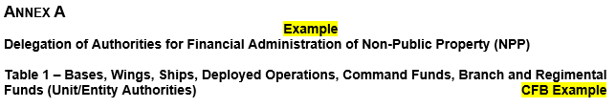
- The Unit or Entity Authority completes para 1 to accept the authorities and responsibilities delegated to them. The incumbent signs and dates the form and adds their certification completion date and NPP ID if known.

If these fields are left blank, the NPP Accounting Office needs to fill in these sections. The NPP certification completion date can be found in the Certification Master spreadsheet, which is maintained by the NAPO. The NPP ID can be found in DataMart or PROPHET using the incumbent’s contact information. If the incumbent does not have a NPP ID, one will be created in DataMart by the supporting NPP Accounting Office.
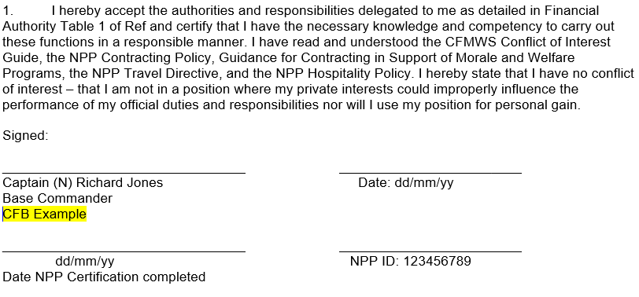

- The Higher, Unit or Entity Authority completes para 2 to delegate NPP financial signing authority to the positions listed. Dependent upon the scope and scale of operations, one or more tables may be required. Tables must list all delegated positions and the area(s) of responsibility for which signing authority is authorized.

Note: The example table below is showing a limited number of delegated positions and areas of responsibility for which signing authority is authorized. If needed Annex A can be oriented to landscape (Layout tab, Orientation, Landscape) and additional rows and columns added to include all delegated position titles and areas of responsibility.

Annotate the Delegated Position Title(s) and Areas of Responsibility for which signing authority is authorized. Enter the amounts to be delegated for each area of responsibility ensuring to stay within the applicable authority limits as detailed in the Unit/Entity Delegation of Authority Table 1.
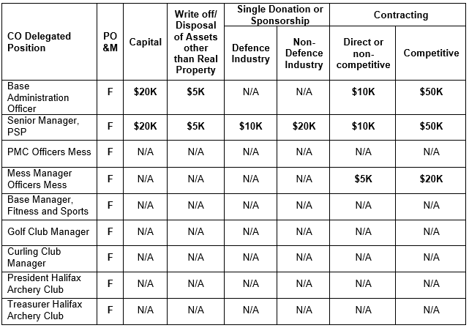
- Update “CFB Example” with the actual Unit/Entity name then have the approving authority sign and date the document to approve the delegated authorities for their Unit/Entity:
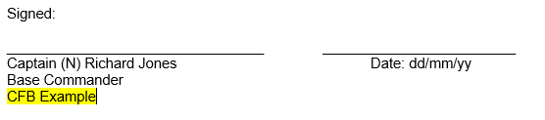
- Send the original signed form to the supporting NPP Accounting Office for action. In turn, the NPP Accounting Office will save the form in the appropriate Delegation of Authority folder.
Note: These authorities are now in effect until such a time as a change is required to a delegated position OR a change is required to an amount being delegated OR the applicable Unit/Entity’s approving authority changes. At those times, a new Annex A will need to be completed to reflect the updated information.

Annex B SOP Table 1 - Bases, Wings, Ships, Deployed Operations, Command Funds, Branch and Regimental Funds (Unit/Entity Authorities)

- Remove the word Example from the top and then replace “CFB Example” with the actual Unit/Entity name:
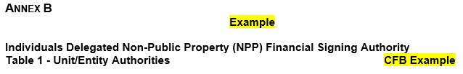
- Annotate the Unit/Entity’s approving authority’s name, telephone number and email address.
- The next section contains the names and contact information for the Unit/Entity delegated positions. This section should mirror the positions listed in Annex A. Add additional rows as needed to identify all positions and fill in all names and contact info for each person who currently holds each position. If a position is currently vacant, indicate such by entering “VACANT” in the Name of Incumbent field and leave the remaining info fields blank:
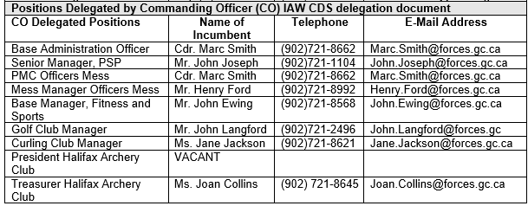
- Replace “CFB Example” with the actual Unit/Entity name then have the Unit/Entity’s Administrative (or Finance) Officer sign and date the document to confirm the individuals who hold delegated authorities for their Unit/Entity:
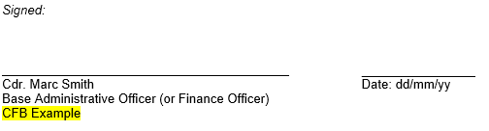
- Send the original completed form to the supporting NPP Accounting Office for action. In turn, the NPP Accounting Office will save the form in the appropriate Delegation of Authority folder.
Note: These authorities are now in effect until there is a change in incumbents OR a change is required to update contact information OR the applicable Unit/Entity’s approving authority changes. At those times, a new Annex B will need to be completed to reflect the updated information.

Annex C SOP Table 1 - Bases, Wings, Ships, Deployed Operations, Command Funds, Branch and Regimental Funds (Unit/Entity Authorities) and NPP organizations that have limited DOA requirements

- Annex C- Standard Procedures: Remove the word “Example” from the top and then replace “CFB Example” with the actual Unit/Entity name:
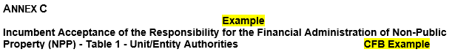
- Info filled out in the table must match the info found on both Annex A (authority and amounts) and B (contact info) except for NPP organizations that have limited DOA requirements and are not required to complete Annexes A & B.
Add rows as needed to include all delegated authorities.
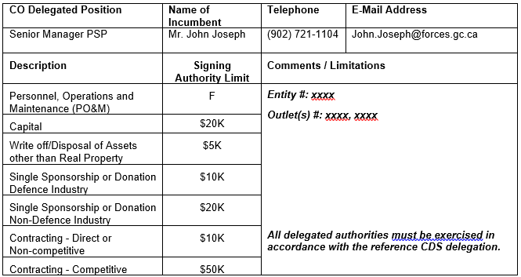
- The incumbent signs and dates the form and adds their certification completion date and NPP ID if known. If these fields are left blank, the NPP Accounting Office needs to fill in these sections. The NPP certification completion date can be found in the Certification Master spreadsheet, which is maintained by the NAPO. The NPP ID can be found in DataMart or PROPHET using the incumbent’s contact information. If the incumbent does not have a NPP ID, one will be created in DataMart by the supporting NPP Accounting Office.
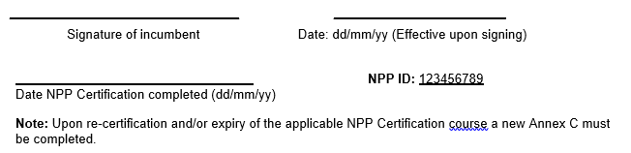
- The incumbent’s direct Manager, Supervisor or Delegating Authority, signs and dates the form before sending it to the supporting NPP Accounting Office who in turn will save it to the appropriate Delegation of Authority folder.

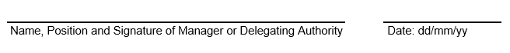
- Annex C – Procedures for NPP organizations that have limited DOA requirements: Remove the word “Example” from the top, amend header to reflect “Delegation and Incumbent Acceptance…”and then replace “CFB Example” with the actual Unit/Entity name.
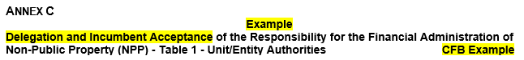
Fill out the table to reflect the actual Delegating Authority Position, Incumbent’s Name, Contact Info, and the Description, Signing Authority Limit, Comments/Limitations fields.
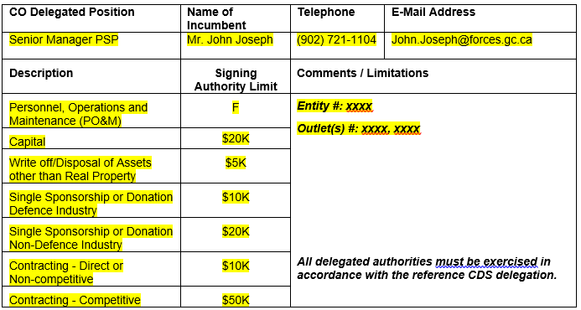

Add rows as needed to include all delegated authorities that apply to the position.
- The incumbent signs and dates the form and adds their certification completion date and NPP ID if known. If these fields are left blank, the NPP Accounting Office needs to fill in these sections. The NPP certification completion date can be found in the Certification Master spreadsheet, which is maintained by the NAPO. The NPP ID can be found in DataMart or PROPHET using the incumbent’s contact information. If the incumbent does not have a NPP ID, one will be created in DataMart by the supporting NPP Accounting Office.
- The incumbent’s Delegating Authority, signs and dates the form before sending it to the supporting NPP Accounting Office who in turn will save it to the appropriate Delegation of Authority folder.

Annex D SOP Table 2 - Delegation and Incumbent Acceptance of the Responsibility for the Financial Administration of Non-Public Property (NPP) for CFMWS and Central Funds (Divisions)
- Annex D is to be used to both delegate authority and accept responsibility for the Financial Administration of NPP for Table 2 – CFMWS & Central Funds (Divisions) only (Annexes A, B & C are not required).
- Remove the word “Example” from the top and replace “CFO Division” with the applicable Division:
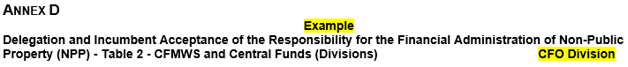
- Replace the “Chief Financial Officer (CFO) Delegated Position” with the actual Divisional Authority (e.g. Senior VP CANEX Delegated Position) or MD NPP as applicable.
- Add rows as needed to include all delegated authorities that apply to the position.
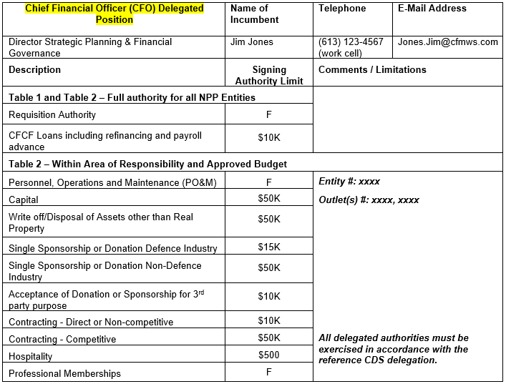
- The incumbent signs and dates the form and adds their certification completion date and NPP ID if known. If these fields are left blank, the supporting NPP Accounting Office needs to fill in these sections. The NPP certification completion date can be found in the Certification Master spreadsheet, which is maintained by the NAPO. The NPP ID can be found in DataMart or PROPHET using the incumbent’s contact information. If the incumbent does not have a NPP ID, one will be created in DataMart by the supporting NPP Accounting Office.
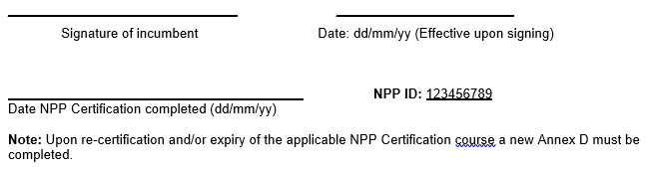
- The incumbent’s Division Head or MD NPP as applicable, signs and dates the form before sending it to the supporting Finance Business Partner and the supporting NPP Accounting Office who in turn will save it will save it to the appropriate Delegation of Authority folder:
